1. 
2. A white board with blue text

   Description automatically generated
3. 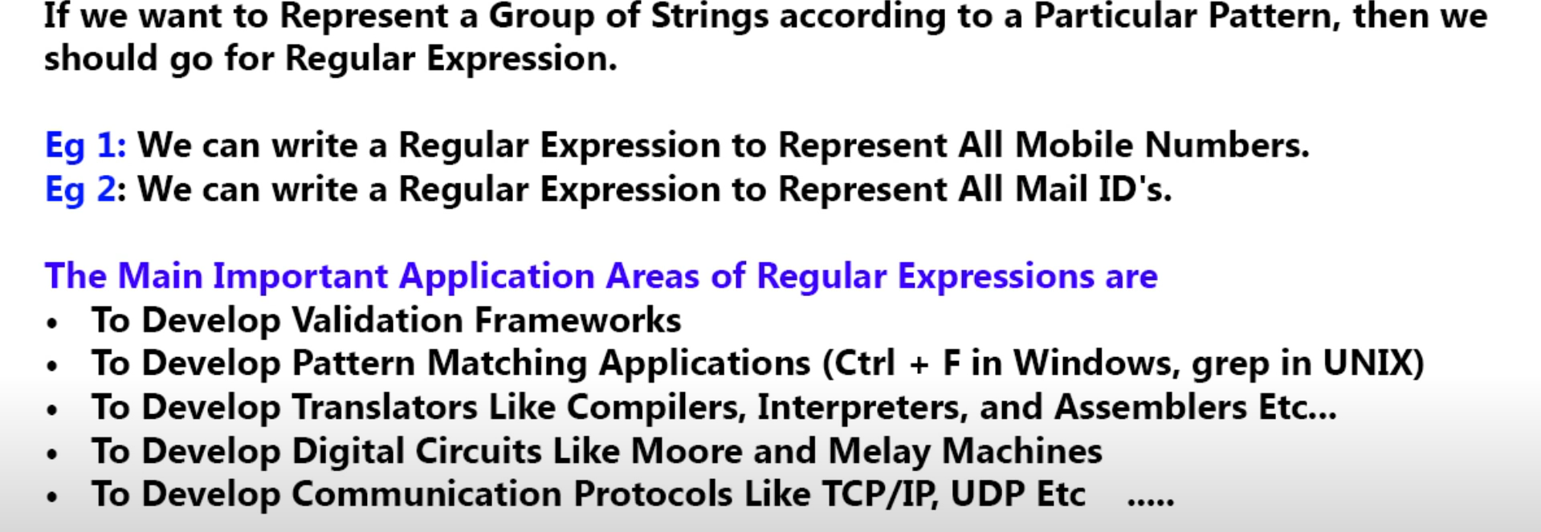
4. Introduced in Java Version 1.4.
5. **Examples : Write an expression** :
   1. To represent all Indian mobile numbers as india mobile numbers are as per pattern.
   2. To represent all yahoo emails.
6. **When to go for Regular Expression**:
   1. When we want to represent a group of strings according to a pattern.
7. **Definition**:
   1. A regular expression is an expression to represent a group of strings according to a pattern.
8. **Examples from a day-to-day life**:
   1. While filling in enquiry form, if we enter email not per rules, we get alert.
   2. The form site will check only format not if the entered email exists or not.   
      Like entering [aaa@bbb.com](mailto:aaa@bbb.com) will be validated but it doesn’t exist.
9. Validation Framework internally checks the validity only by using Regular Expression.
10. Pattern matching app which enables us to find some chunk throughout the doc.  
    Like CRL + F.  
    This command is implemented using Regular Expression.
11. **We can use Regular expression to develop**.
    1. Validation Framework : Like form validation.
    2. Pattern Matching App : Like CRL + F.
    3. Compiler Designing: Stages are 🡺
       1. Lexical Analysis.
          1. Also known as Scanning or Tokenization.
          2. This stage is implemented using **Regular Expression**.
       2. Syntax Analysis.
       3. Semantic Analysis.
       4. Intermediate Code Generation.
       5. Code Optimization.
       6. Target Code Generation.
    4. Digital Circuits such as
       1. Adder
    5. To develop communication protocols as protocol is a set of rules what is allowed or not.
       1. TCP, UDP
12. We will cover the 1st two areas as per our scope.